Key outcome name: Freshwater for Delta exports

Authors: James Gilbert^{1,2*}, Dino Bellugi³, Abhinav Sharma¹, Khandaker Iftikhar Islam¹

*Corresponding author: James Gilbert, james.gilbert@ucsc.edu

¹ University of California, Santa Cruz, Institute of Marine Sciences’ Fisheries Collaborative Program, 1156 High Street, Santa Cruz, California 95064, U.S.A.
² Fisheries Ecology Division, Southwest Fisheries Science Center, National Marine Fisheries Service, National Oceanic and Atmospheric Administration, 110 McAllister Way, Santa Cruz, California, 95060, U.S.A.
³ University of California, Berkeley, Department of Environmental Science, Policy and Management, 130 Mulford Hall #3114, Berkeley, CA 94720-3114

Background
The Sacramento-San Joaquin Delta serves as a conveyance hub for water being moved from storage in the comparatively wetter Sacramento River basin reservoirs to users in the drier San Joaquin and Tulare basins, the Central Coast and Southern California. Water is exported from the south Delta via two major pumping facilities. One, the Tracy (or Jones) pumping plant is operated by the Central Valley Project (CVP). The other, the Banks pumping plant, is operated by the State Water Project (SWP). These exports are a crucial variable for assessing the performance of the two projects as they support deliveries to cities and farms across a large span of the state. Furthermore, the amount and quality of water exported depends on a number of factors including upstream water availability and supply, currently controlling Delta regulatory conditions, downstream need and storage capacity (e.g. in San Luis reservoir), and salinity conditions in the Delta.
The community water system deliveries and agricultural revenues key outcomes (evaluated separately) overlap somewhat with the Delta exports key outcome in that a portion of the locations of interest (LOIs) represented in those key outcomes may be served by Delta exports. However, those key outcome levels rely on LOI-specific conditions and contexts (e.g. value of crops, independently defined thresholds for municipal supply sufficiency) and do not explicitly assess the volumetric and water quality performance of the Delta export pumps. Additionally, the community water system and agricultural revenue key outcome levels include LOIs that are upstream (and thus not served by) the Delta export pumps and thus represent a footprint incongruent with Delta exports. The Delta export key outcome serves as complement to these other key outcome types by assigning a score directly to the volume and salinity of water exported from the two south Delta pumps.
The general concept behind this outcome level formulation is that, over a 100-year CalSim3 simulation, export volumes that are closer to the cumulative available capacity while maintaining a preferred low salinity (<900 uS/cm) level are ideal (an upper bound for a Level 1 designation). Conditions that support high levels of exports but do so in a way that entrains saltier water in the export pumps should be penalized with a less desirable (higher numerical value) outcome level designation. Similarly, scenarios that lead to reduced cumulative export volumes would have a less desirable outcome level value.
Historically, upstream and Delta operations have been managed to maintain consistent and desirable salinity levels at the Banks and Jones pumping plants. The CalSim3 model estimates salinity at these locations through an empirical (regression) model that, in turn, relies on the salinity estimates at the Rock Slough location produced by an artificial neural network emulator of the hydrodynamic model DSM2. Initial evaluations of the two export locations for a range of scenarios indicated that the model very rarely simulates salinity above 900 uS/cm, indicating that 1) the model is generally consistent with recent reality and 2) salinity alone may not be a useful metric by which to measure Delta export performance. Using the occurrence of salinity above the 900 uS/cm threshold to reduce the weight of corresponding export volumes in a cumulative total, however, allows this information to be integrated into a predominantly volumetric measure.
The weighting rules we adopted for the outcome level formulation assign a full weight (a value of 1.0) for all monthly export volumes for which the estimated salinity at that pump is less than or equal to 900 uS/cm. For estimated salinity values greater than 2500 uS/cm, the weight value is 0.0 - essentially removing that month’s export volume from the cumulative tally. For salinity values between 900 uS/cm and 2500 uS/cm, the weight varies linearly from 1 to 0 as salinity increases. This weighting structure is illustrated in the stylized plot in Figure 1.
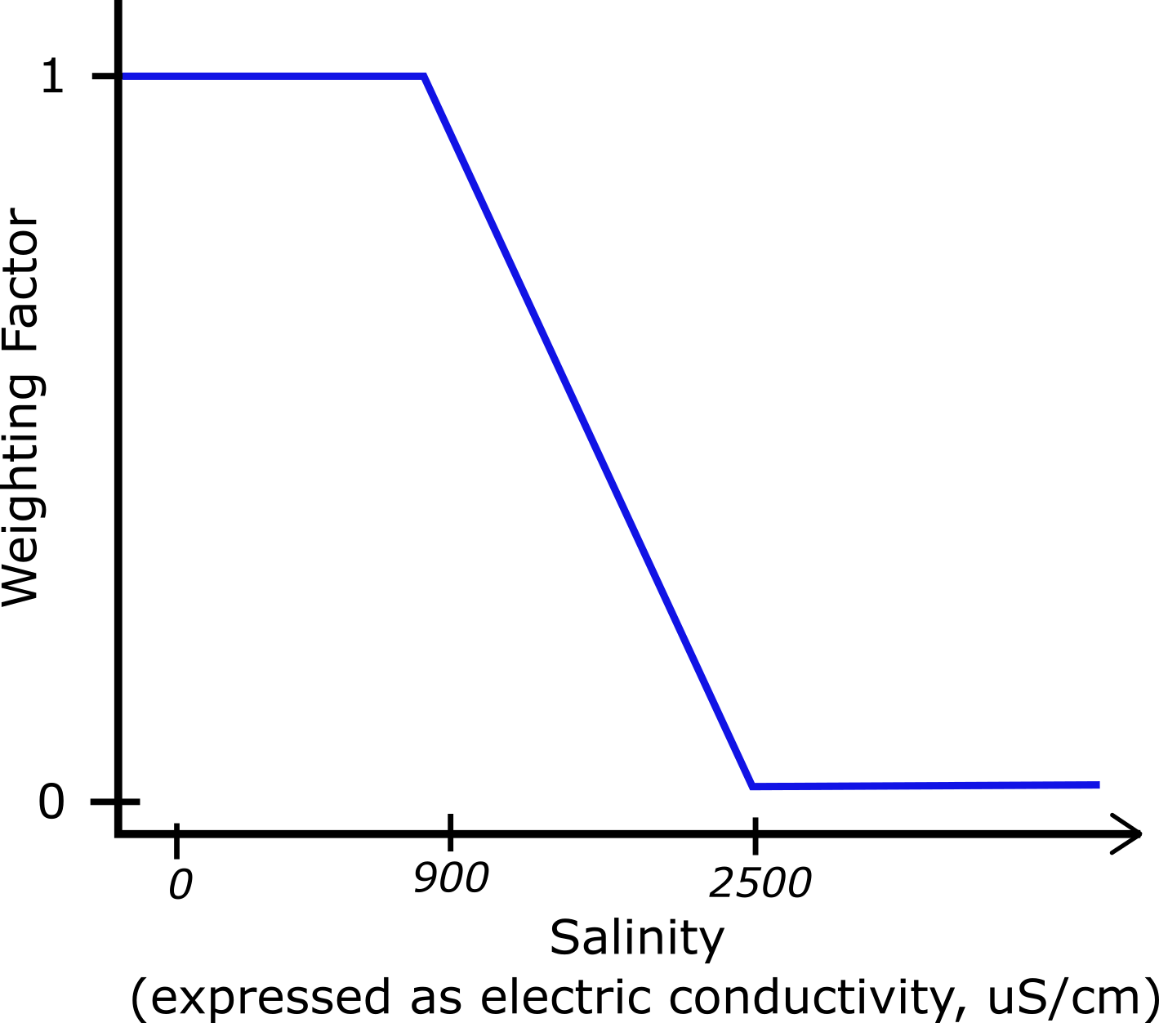
Add figure caption.
Figure 1. Weighting structure for salinity-weighted export volumes. Weights vary linearly between 1 and 0 as salinity increases for values between 900 uS/cm and 2500 uS/cm.
The salinity-weighted export volumes are accumulated for each pumping location for the entire 100-year CalSim3 simulation period (1200 monthly time steps). The outcome level designation is then set for a scenario based on how the weighted cumulative volumes compare to different thresholds. The details of the method and data processing are provided in the Methods section, below.

Locations of Interest
This outcome level is calculated as a single value per scenario based on data at two locations of interest: the CVP (Tracy/Jones) pumping plant and the SWP (Banks) pumping plant. The locations of the pumping plants within the Delta region are shown in Figure 2. The CalSim3 variable names for these two locations are /TRACEC_MAX14DAY/ (for the CVP Tracy/Jones pumping plant) and /BANKSEC_MAX14DAY/ (for the SWP Banks pumping plant). As implied by the variable names, the CalSim3 variables reprepresent the estimated 14-day maximum value within a month rather than a monthly mean, as was used for the in-Delta salinity key outcome. The 14-day maxima are the only variables calculated for the pumping plants within the CalSim3 model files used as the basis for COEQWAL scenarios and thus represent the best available option for including salinity at the Delta pumps. If daily salinity is variable throughout a month, the 14-day maximum should be higher than the monthly mean. Using this variable will tend to provide an outcome level result that emphasizes salinity impacts slightly more than if the monthly mean was used.
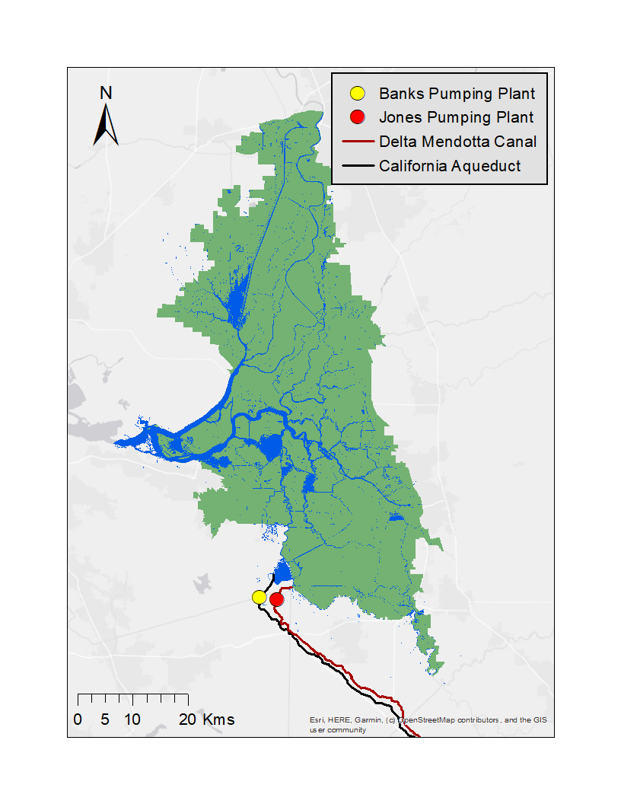
Figure 2. Map of the Sacramento-San Joaquin Delta with the two export pumping stations highlighted in the south Delta. The State Water Project’s Banks Pumping Plant is shown in yellow. The federal Central Valley Project’s Jones Pumping Plant is shown in red.

Methodology
Outcome levels reflect the total amount of fresh water exported from the Delta pumps (Banks, Jones) over the 100-year simulation period. For this outcome level calculation, the volume of water pumped at either pumping location is reduced proportionally by the amount the salinity of that water exceeds 900 uS/cm. Water pumped with salinity greater than 2500 uS/cm is assigned a 0 value (see Figure 1, above). Outcome levels are defined based on the combined total volume pumped at each pumping location for the 100-year period.

Discrete key outcome level
Level 1 is assigned when total combined salinity-penalized export volume pumped at Banks and Jones pumping plants is greater than 505 million acre-feet, Level 2 if greater than 465 million acre-feet but less than 505 million acre-feet, Level 3 if is greater than 400 million acre-feet but less than 465 million acre-feet, and Level 4 otherwise (e.g. < 400 MAF). These thresholds are based on approximate percentages of maximum physical pumping capacity for the 100-year CalSim3 simulation period. The percentages are roughly 61% (505 MAF), 56% (465 MAF), and 48% (400 MAF) and were selected based on a review of CalSim3 baseline model results and recent historical data.
Table 1. Delta export volume and salinity thresholds and outcome level definitions.
Low Salinity Threshold | High Salinity Threshold
900 uS/cm | 2500 uS/cm
Outcome level | Salinity-adjusted volume
1 | >= 505 MAF
2 | >= 465 MAF and < 505 MAF
3 | >= 400 MAF and < 465 MAF
4 | < 400 MAF

Continuous key outcome level
Continuous values are based on the concept of progress to locate each scenario within its assigned discrete outcome level interval. For each outcome level, progress is calculated by linearly interpolating the total annual export volume between the upper and lower bounds of that outcome level. A progress value near 0 indicates performance close to the stronger end of the outcome level (higher exports), while a value near 1 indicates performance close to the weaker end (lower exports). This progress value is then added to the discrete outcome level number to produce a continuous score within the outcome level range, preserving the discrete classification while providing finer differentiation among scenarios. For example, if exports are 35% of the way way between the Level 2 and Level 3 cutoff, while being closer to Level 2, the continuous outcome level value would be 2.35.
For Levels 2–4, progress is computed directly using the predefined export thresholds that define each outcome level boundary. Level 1 requires special treatment because export volume is not theoretically bounded above, meaning there is no fixed upper limit to define the strongest possible Level 1 case. To address this, the code derives the Level 1 upper reference point empirically from the dataset by taking the maximum observed export volume among all Level 1 scenarios. Progress within Level 1 is then measured relative to this data-derived maximum and the Level 1 threshold boundary, allowing Level 1 continuous values to be scaled consistently within the interval [1,2).
Appendix S-1 contains pseudocode outlining the complete outcome level assignment procedure. Python code that extracts the required CalSim3 variables and performs the outcome level calculations is available on GitHub at https://github.com/canruso/COEQWAL_V3/tree/main/notebooks (notebook) and https://github.com/canruso/COEQWAL_V3/blob/main/coeqwalpackage/tier.py (functions).
The outcome level formulation produces discrete values in the range 1-4 and continuous values in the range 1.0 - 4.99. Values closer to 1 indicate a higher total export volume with low salinity and values of 4 (or greater for the continuous version) indicate lower export volumes, higher salinity, or some combination of the two. The thresholds that demarcate the different outcome level levels were chosen such that current operations with historical hydrology, and now sea level rise, tend to fall within the Level 2 range. This means that a Level 1 result would be an improvement over the current operations baseline and Levels 3 and 4 would be incremental degradation of export performance. The cumulative salinity-penalized export volumes (combined across both export pumps) that define the discrete outcome levels are shown in Table 1.

Because each scenario only produces a single outcome level, results are not conducive to graphical summaries or maps. However, results across many scenarios can be summarized easily into tables or other figures.

Guidelines for Interpretation

The structure of the Delta export outcome level supports a relatively simple and straightforward interpretation. As noted above, the outcome levels indicate an incremental decrease in cumulative export of fresh water over the 100-year CalSim3 simulation period, with a Level 1 designation being the highest export volume and Level 4 being the lowest. The discrete and continuous outcome levels are interpreted in the same manner, with the continuous values providing a linear interpolation of the export volume between the discrete boundaries. In other words, an outcome level value of 2.5 should be interpreted as being halfway between a Level 2 and Level 3 designation.
This outcome level is designed to summarize aggregate model response – essentially assigning a score to rate how much total fresh water can be exported for a given scenario – and does not reflect variations at individual pumping locations or time periods that may be relevant for certain purposes. For example, allocations for south-of-Delta deliveries are commonly reduced during droughts, which would be expected to translate to lower than normal export pumping and possibly increased salinity at the pumps. The Delta export outcome level would not be a useful means of detecting the effect of these sorts of reductions if they tend to be infrequent or small in magnitude compared to the normal pumping rate. A different set of rules that focus on some combination of variation and total volume pumped during specific periods would be needed if such characteristics are the target for interpretation.
The Delta exports outcome level is also limited in the explicit consequences denoted by an outcome level designation – a certain outcome level result does not necessarily guarantee shortages or surplus for a particular end user. The other outcome levels created for COEQWAL measure many local and domain-specific outcomes and are better suited for evaluating how a scenario affects particular locations and water users. We acknowledge that export volumes in many cases will be correlated with deliveries to agriculture and municipal end users but note that the additional context incorporated in the agricultural and community water system outcome levels provide more useful interpretive context than a strictly volume-based outcome level like this one.
Finally, the cumulative export volumes selected as outcome level boundaries for this analysis were based on an inspection of recent historical annual delivery amounts, common ranges simulated in CalSim3 baselines, and a modest extrapolation to account for variation across extreme hydroclimates. This generalized approach was ultimately selected for its ease of application and simplicity in interpretation. While the outcome level designations provide a sensible summary of Delta export variation across the full range of hydroclimate and operations conditions simulated, it is not necessary that these boundary volumes be fixed at these values. If an outcome or consequence of particular interest is tied to export volumes or export salinity of a certain level, the threshold volumes used to assign outcome level values could easily be adjusted to accommodate this.

References
Python code used to calculate the in-Delta salinity outcome level values is provided on GitHub at:
https://github.com/canruso/COEQWAL_V3/blob/main/coeqwalpackage/tier.py (function)
https://github.com/canruso/COEQWAL_V3/blob/main/notebooks/Tier_Assignment_Salinity.ipynb (notebook)

Appendix

Appendix S-1. Outcome level assignment pseudocode.

The complete outcome level assignment procedure is illustrated by the following pseudocode. In the pseudocode, outcome levels are referred to as ‘tiers.’
FOR each scenario:
==================================================
STEP 1: Compute quality-adjusted export volume
==================================================
FOR each export facility
(Banks and Tracy):
Extract:
Salinity time series
Export volume time series

Compute a salinity weight:
weight =
(TopThreshold − Salinity)
/
(TopThreshold − LowThreshold)

Limit the weight to the interval
[0,1]

Compute quality-adjusted export:
AdjustedVolume =
ExportVolume × Weight

Store:
Salinity
Export Volume
Weight
Adjusted Volume

==================================================
STEP 2: Compute total export volumes
==================================================
FOR each export facility:
Compute
Total_Volume =
sum of Export Volume

Total_AdjVolume =
sum of Adjusted Volume

Compute
Total_AdjVolume_Total =
Total_AdjVolume_Banks
+
Total_AdjVolume_Tracy

==================================================
STEP 3: Assign export tiers
==================================================
FOR each export category
Banks
Tracy
Total

----------------------------------------------
STEP 3.1: Define tier boundaries
----------------------------------------------
Read the three adjusted-volume thresholds
B1
B2
B3

Ensure
B1 > B2 > B3

----------------------------------------------
STEP 3.2: Assign discrete tier
----------------------------------------------
Let
TotalExport =
total quality-adjusted
export volume

IF TotalExport >= B1
discrete tier = 1

ELSE IF TotalExport >= B2
discrete tier = 2

ELSE IF TotalExport >= B3
discrete tier = 3

ELSE
discrete tier = 4

----------------------------------------------
STEP 3.3: Define interpolation limits
----------------------------------------------
IF Tier 1
BetterBoundary =
maximum Tier 1 export
volume among all level 1 scenarios
WorseBoundary =
B1

ELSE IF Tier 2
BetterBoundary =
B1
WorseBoundary =
B2

ELSE IF Tier 3
BetterBoundary =
B2
WorseBoundary =
B3

ELSE
BetterBoundary =
B3
WorseBoundary =
zero export

----------------------------------------------
STEP 3.4: Compute within-tier progress
----------------------------------------------
progress = 0
strongest performance
within the tier
progress = 1
weakest performance
within the tier

IF Tier 1
progress =
(BetterBoundary − TotalExport)
/
(BetterBoundary − B1)

ELSE IF Tier 2
progress =
(B1 − TotalExport)
/
(B1 − B2)

ELSE IF Tier 3
progress =
(B2 − TotalExport)
/
(B2 − B3)

ELSE
progress =
(B3 − TotalExport)
/
B3

Clamp progress to remain
strictly within (0,1)

----------------------------------------------
STEP 3.5: Compute continuous tier
----------------------------------------------
continuous tier =
discrete tier + progress

Store:
Discrete export tier
Continuous export tier

==================================================
STEP 4: Save results
==================================================
Store the export tier assignments
for each scenario and export category.

If continuous tiers are requested
Output continuous export tiers
Else
Output discrete export tiers

Python code that extracts the required CalSim3 variables and performs the outcome level calculations is available on GitHub at https://github.com/canruso/COEQWAL_V3/tree/main/notebooks (notebook) and https://github.com/canruso/COEQWAL_V3/blob/main/coeqwalpackage/tier.py (functions).

